Lucas Swanson
4/20/2025
Software Engineering Methods
Exercise 3.4
Steps for a pull request:
- First step is to start with a repository that you have cloned locally. This is so that we can push a feature branch to an remote feature branch and create a “Pull Request”.
  - This is what your visual git should look like at the beginning:
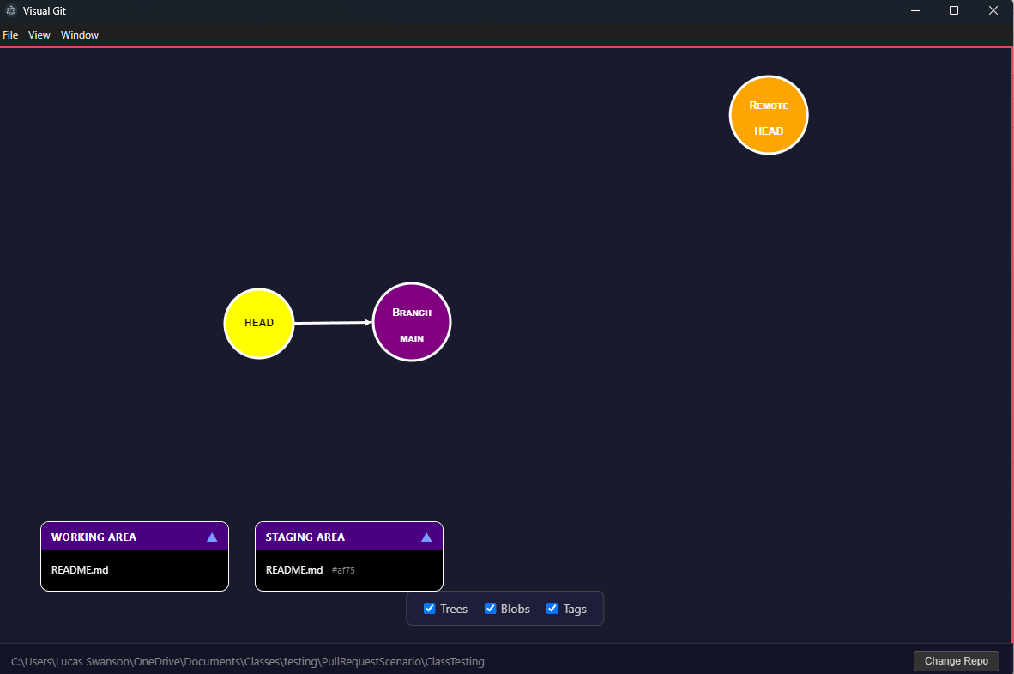
- Next we need to swap to a feature branch. Let’s just call it ‘ABXYFeature”
  - 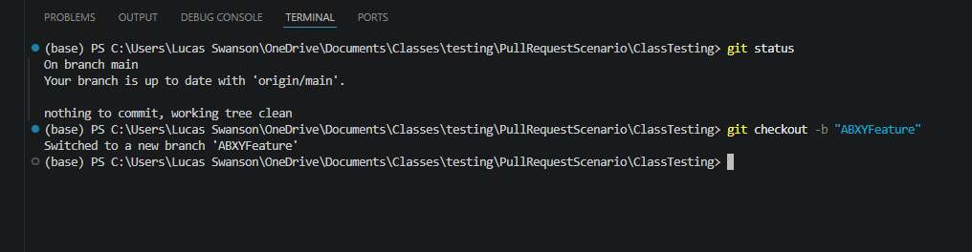
  - 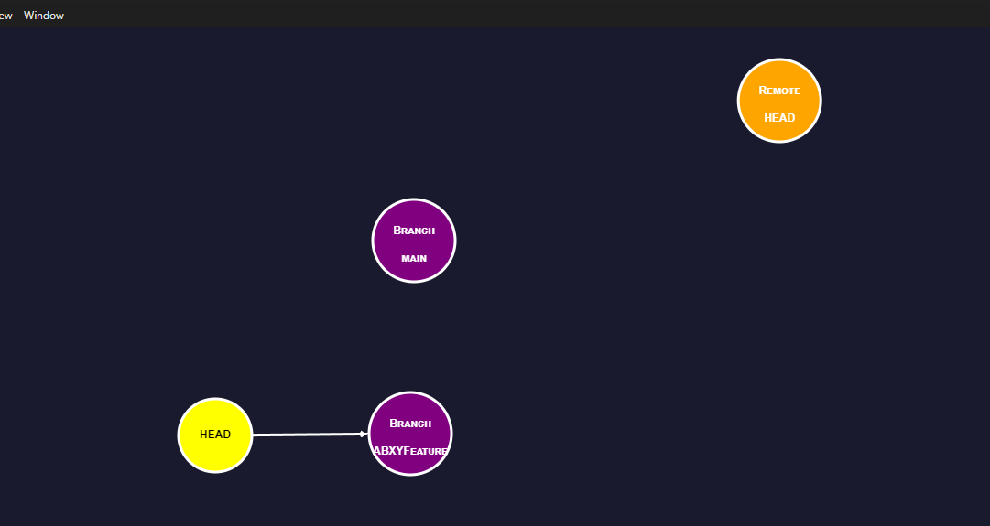
- Next we need to create the files to upload to our feature branch. Use the following as a template and commit the files:
  - 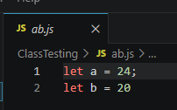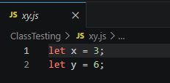
  - 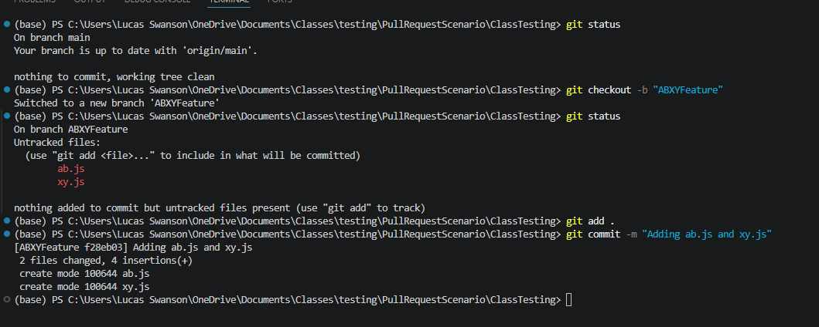
  - 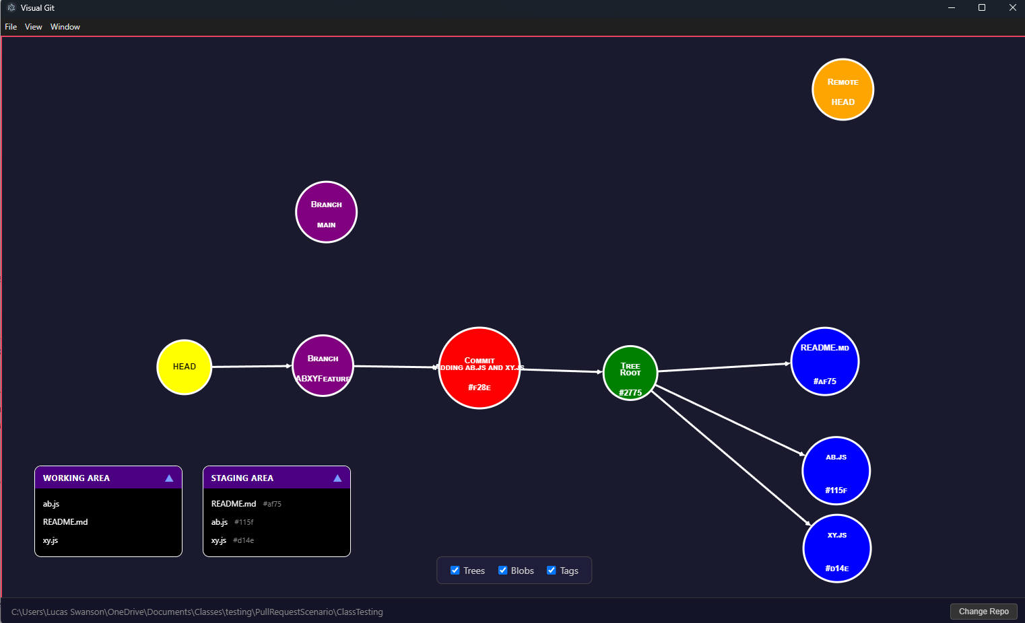
- Now once you have these there is no remote branch to push these to, so when you try git terminal will tell you to use the command “git push --set-upstream origin ABXYFeature”. Do this and your visual git will reflect the new upstream branch:
  - 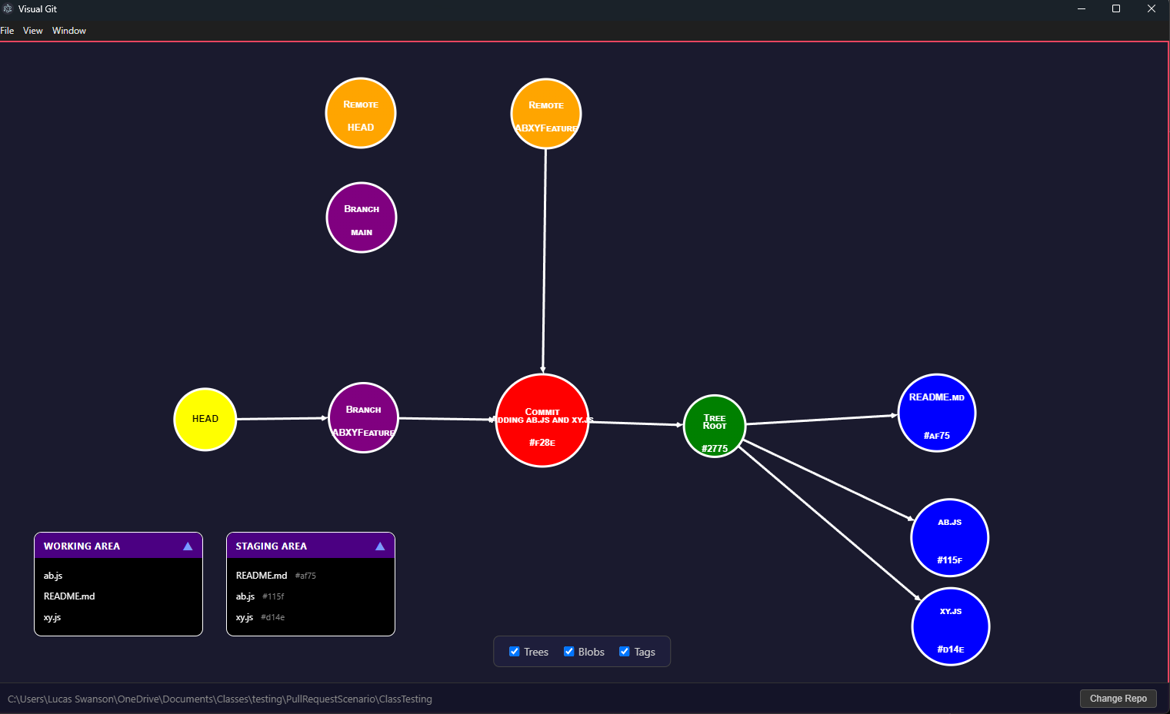
- Now that we can see a new remote feature branch, we can create a pull request to bring this to the remote main branch. You can do this one of two ways:
  - Use the terminal commands:
git fetch origin
git merge origin ABXYFeature
  - Use the github.com website to open a PR
- Once you have your PR created, you should have an option to view it on the remote website:
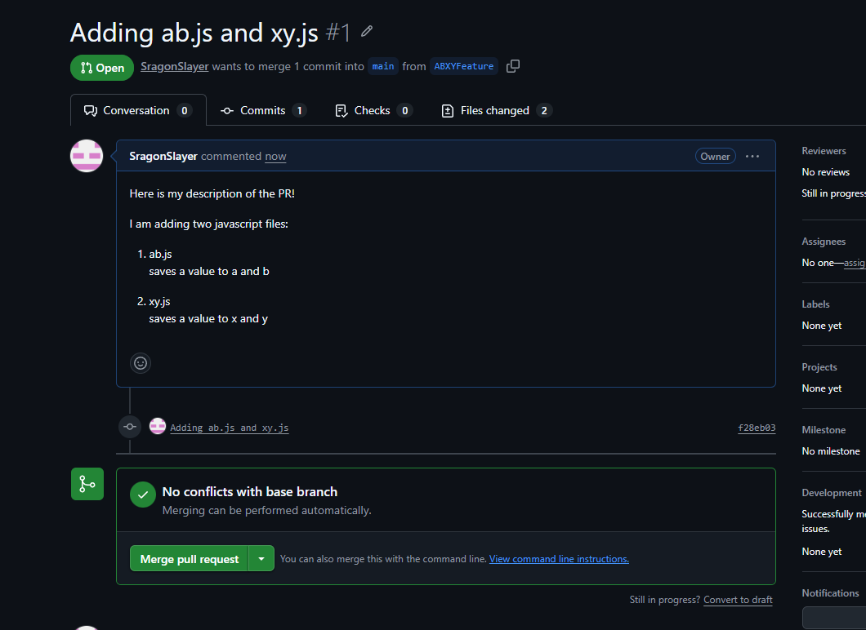
This is useful to get feedback from others before merging or go through automated test steps to ensure your code works as expected.
At this step your visual git will not update yet! Only once merged will the visual git update.
- Now go ahead and click the button to “Merge pull request” and pull locally
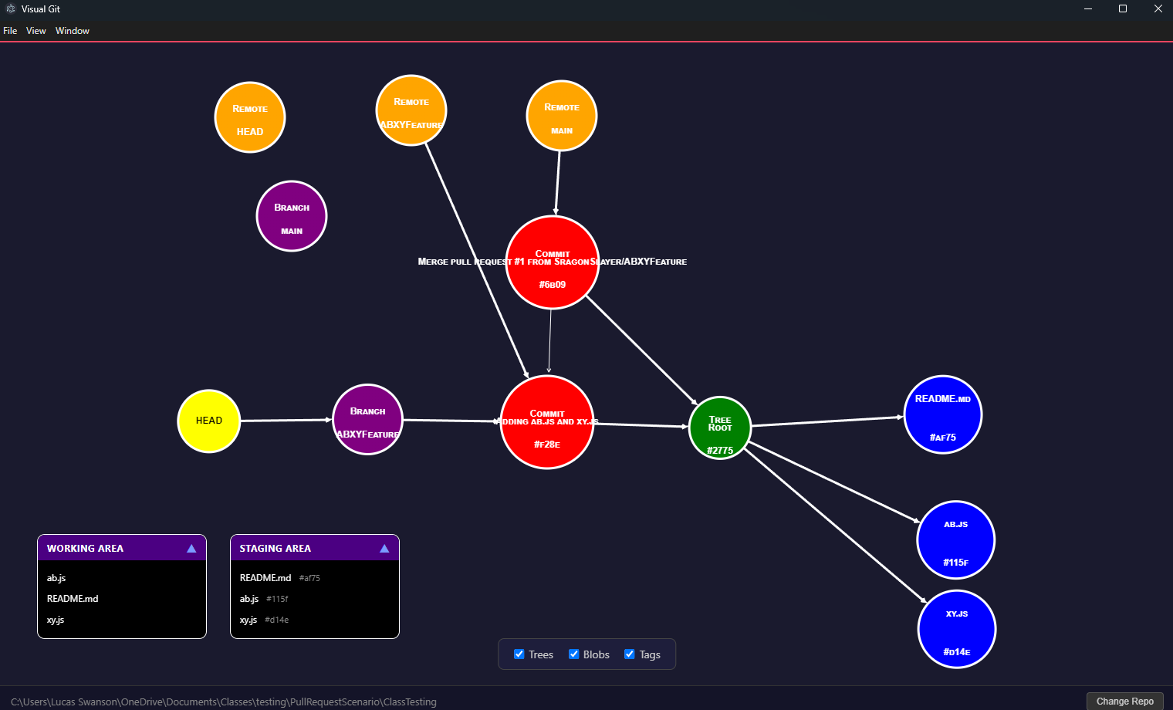
And you will notice that after the PR, remote Main now points to a “Merge Pull Request” rather than directly to the commit we made.
You have made a pull request!

The only thing left to do is delete the feature branch using the command “git branch -d ABXYFeature”, to get the final Visual Git result:
